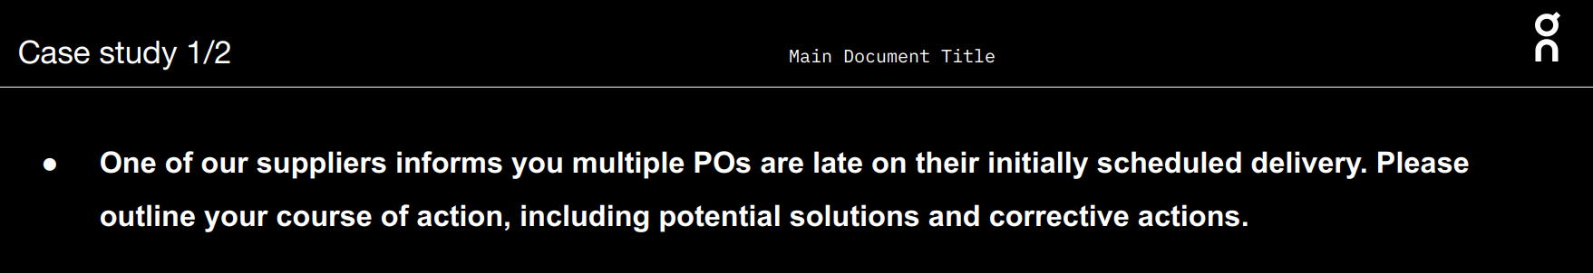

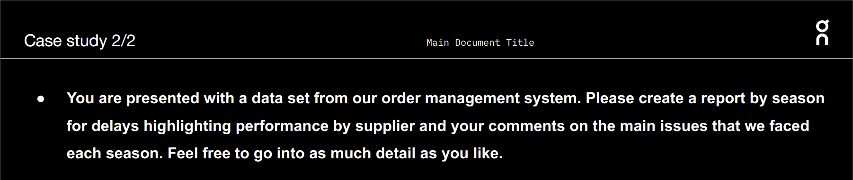

Cleaning the raw data

Step 1: Remove duplicates (4 duplicate values)

Step 2: I realized that the format of some date columns is not correct

They are, for example 02.03.23 (E2 cell)

So, I use the function: =DATE(MID(E2,7,2)+2000,MID(E2,4,2),LEFT(E2,2)) to transform it to date value

Output: 3/2/2023

Step 3: There are 12 values of SS22 in “Requested XF date” column are 01.01.00 -> incorrect because Order Date is in 10.11.22 so it is impossible the Requested XF date is in 01.01.00

I see the Order Date in 11/2022 so it may take 3 months for the products leave the factory, so I fix the 01.01.00 to 01.01.23 (also based on Fty. 1st Conf. Ready Date in 2023 and Current Ex-Fty. Date in 2023)

Step 4: There are 3 suppliers do not have the Current Price/Piece ($)

OVERCLOTHES S.p.A.

STONETEX MANUFACTURING SA

Gunther Bohr GMBH

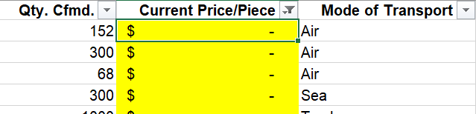

* I base on the price of similar model to fill the price of those blank cells

Step 5: I realize that the “Article” column has two formats:

1 - 355.01375

2 - 1MD30301469

And Article is the combination of Style and Color code

Example: 355.01375 (Article) -> 355 is Style and 01375 is Color code (1)

On the other hand, with Article has format 2, the Style and Color code are not correct

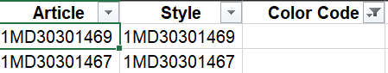

Correct one:

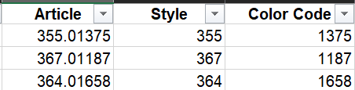

I use the function:

=IF(ISNUMBER(H2), TEXT(H2,"0.00000"), MID(H2,4,3) & "." & TEXT(MID(H2,7,5),"00000"))

to transform the values in this column in just a format like 1, eliminate format 2.

After that, I use the right and left function to fix the Style and Color code column following (1)

* Style: =LEFT(I2,3) (Article new in I2)
* Color code: =RIGHT(I2,5)

Output:

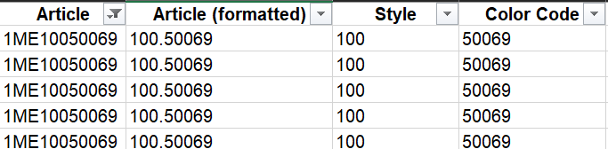

Import the clean data into Power BI and build the dashboard

Step 1: Import data as an Excel file into Power BI

Step 2: Use Power Query to clean the data

1 – Transform Article, Style and Color Code into Text instead of Number format

2 – Remove blank rows

Data Analysis

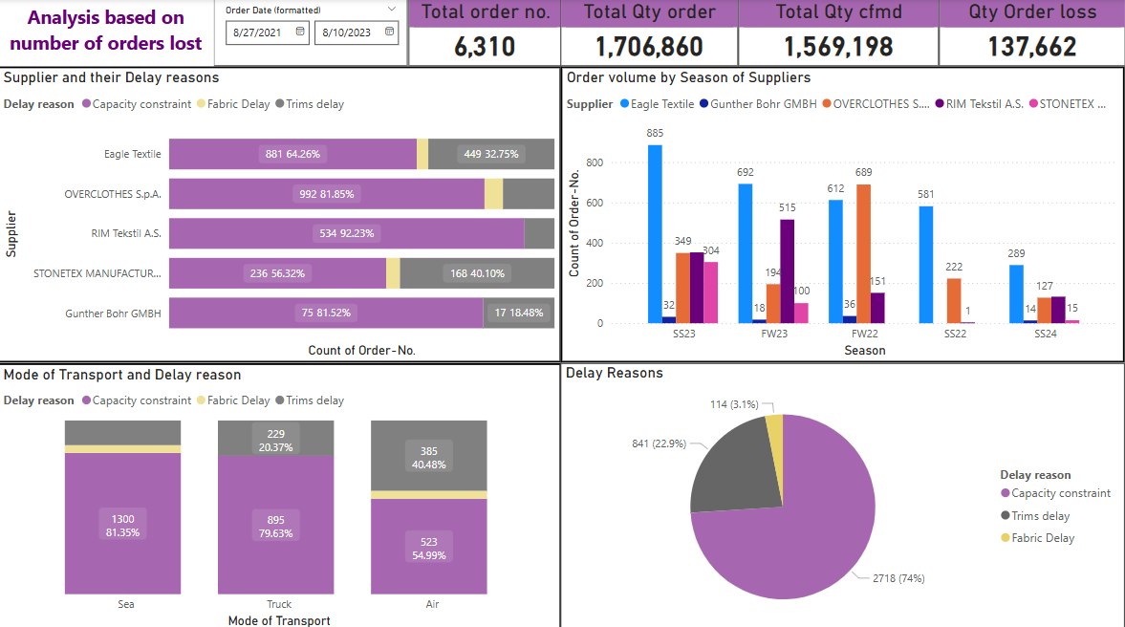

Based on orders, we can see that Capacity constraint (2718 ~ 74%) is the most frequent reason occurs with the company order. While OVERCLOTHES S.p.A, is the supplier has the most capacity constraint volume with 992, Rim Tekstil A.S.’ s capacity constraint volume accounts for a large part of their total volume (534). There is a spotlight in air transportation mode that it has a big volume of trims delay compared to other transports at 385.

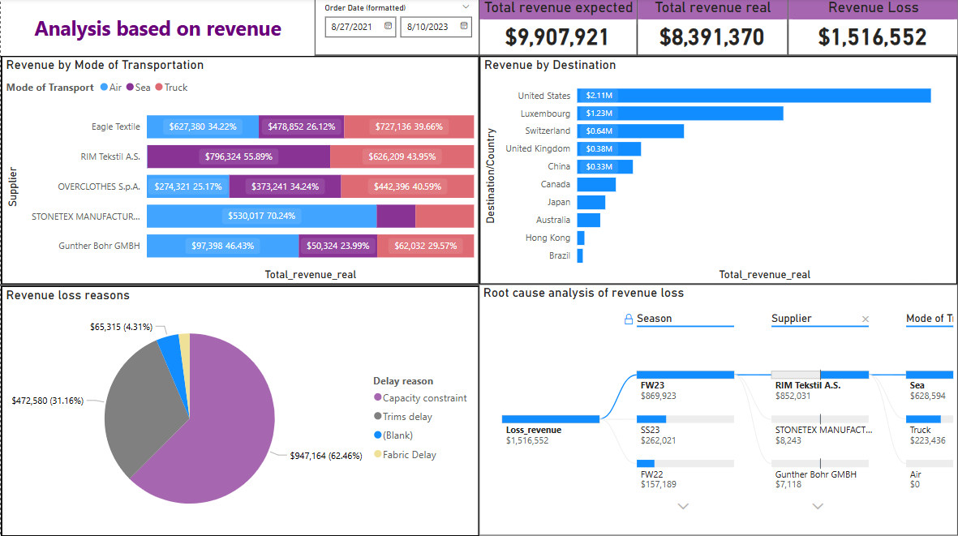

In the next step, I count the revenue loss (Loss_revenue = [Total_revenue_expected] - [Total_revenue_real]) and deep dive into the root cause of revenue loss. As expected, Capacity constraint accounts for 62.46% revenue loss. Moving to the root cause analysis, I gain the result that most of revenue lost in FW23 due to Rim Tekstil A.S. on Sea transportation mode as Capacity constraint reason. And the company lost revenue on top 5 models: Club Hoodie, Club Pants, Club Crew, Graphic Club Hoodie, Club T. And the customer of these models located mainly at United States, China, Canada,…

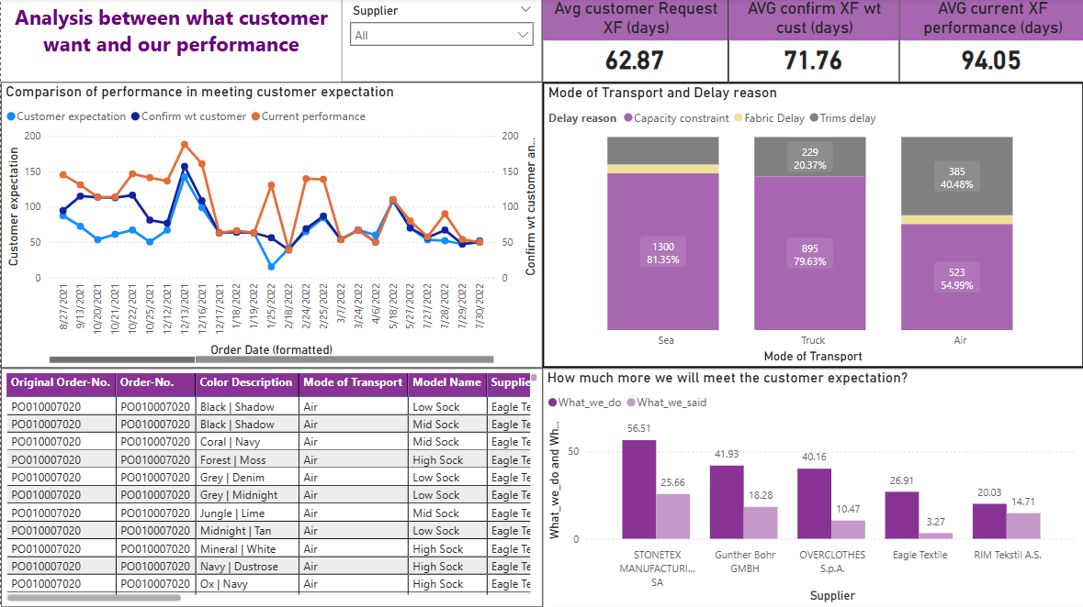

Performing analysis on customer expectation, I have calculated 3 Measures:

* AVG_customer_expectation = AVERAGE(Raw_data[Rquested_XF_period (customer_expectation)]) expresses the period that customer request the company to deliver
* AVG_confirm_wt_customer = AVERAGE(Raw_data[1st_XF_period_cf_wt_customer]) expresses the period the company confirm to deliver to the customer
* AVG_current_performance = AVERAGE(Raw_data[Current_performance_period]) expresses the real period that the company is delivering on each order.

We can see that the company is far from reaching goal of 94.05 – 62.87 = 31.18 days/each item. Supplier STONETEX MANUFACTURING SA contributed the largest delay volume to this situation with a quite big gap (56.51 – 25.66 = 30.85 days/each item). This supplier has air volume as the biggest and 160 orders in that occur Trims Delay. While RIM Tekstil A.S. has the smallest gap of meeting customer expectation (20.03 – 14.71 = 5.32 days) – best lead time performance.